Instagram Engagement Analysis Report

Author
Pratikshya Panda
B.Tech CSE

1. Introduction
Social media platforms like Instagram play a critical role in digital marketing and brand visibility. Understanding user engagement patterns helps organizations optimize content strategy and maximize reach.
This project focuses on analysing Instagram data to identify key factors affecting engagement such as posting time, content type, and user interaction behaviour.

2. Objectives
- Analyse user engagement patterns across posts
- Identify optimal posting time and day
- Evaluate performance of different content types
- Measure engagement rate (likes + comments per follower)
- Provide actionable recommendations for improving engagement

3. Dataset Description
Source: https://www.kaggle.com/datasets/bhanupratapbiswas/instgram
The dataset includes multiple components of Instagram activity:
- Users – account details and activity
- Photos – post-related data
- Likes – user interactions with posts
- Comments – textual engagement data
- Follows – follower relationships
- Tags – hashtag information
The data was collected from a publicly available dataset and processed for analysis.

4. Methodology
4.1 Data Preprocessing
- Handled missing values
- Standardized column names
- Converted date/time fields into proper datetime format
- Transformed categorical values (yes/no → boolean)

4.2 Database Creation
A relational database was created using SQLite with the following tables:
- Users
- Photos
- Likes
- Comments
- Follows
- Interactions
This improved data organization and enabled efficient querying.

4.3 Feature Engineering
- Calculated engagement rate:
- Engagement Rate = (Likes + Comments) / Followers
- Extracted:
  - Hour of posting
  - Day of posting
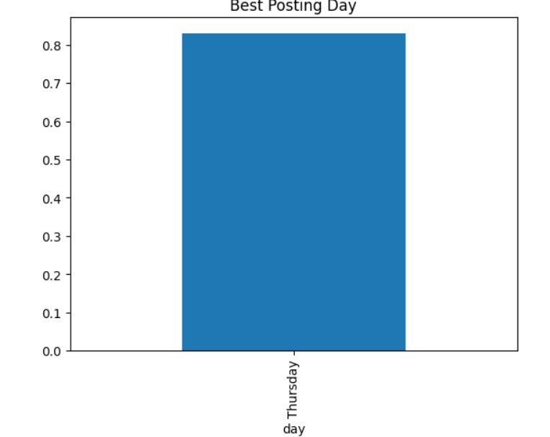

5. Analysis & Results
5.1 Best Posting Time
Engagement was analysed across different hours of the day.
- Observation:
Certain hours show significantly higher engagement, indicating peak user activity periods.

5.2 Best Posting Day
Engagement was compared across all days of the week.
- Observation:
Some days consistently outperform others, suggesting optimal posting days.

5.3 Content Type Analysis
Different types of content were analysed to determine performance.
- Observation:
Specific content types generate higher engagement compared to others.

5.4 Follower Growth Analysis
Follower activity was tracked over time.
- Observation:
Growth trends indicate that consistent posting and interaction contribute to increased followers.

6. Key Insights
- Engagement varies significantly based on posting time
- Content type plays a major role in performance
- Posting consistency positively impacts follower growth
- Early engagement influences overall reach

7. Recommendations (For Alfido Tech)
- Optimize Posting Time
Post during peak engagement hours to maximize visibility and reach.
- Focus on High-Performing Content
Increase the frequency of content types that generate higher engagement.
- Use Hashtags Strategically
Use a balanced number of relevant hashtags to improve discoverability.
- Maintain Consistent Posting
Follow a regular posting schedule on high-performing days.
- Improve Audience Interaction
Respond to comments and use call-to-action strategies to increase engagement.

8. Conclusion
This project demonstrates how Instagram data can be transformed into actionable insights using data analysis techniques. By leveraging engagement metrics and behavioural patterns, organizations can significantly improve their social media performance.

9. Future Work
- Build a machine learning model to predict engagement
- Develop an interactive dashboard (Power BI/Tableau)
- Perform sentiment analysis on comments

